ASSIGNMENT 23.2

Veerla Sathvika
2303A52434
Batch 38

Task 1 – Project Proposal
• Students choose a real-world problem to solve with an AI-
assisted application (e.g., e-commerce billing system, health
monitoring dashboard, student attendance tracker).
• Prepare a project proposal including:
o Objective
o Features
o Tools/technologies to be used
o Expected output

Prompt:
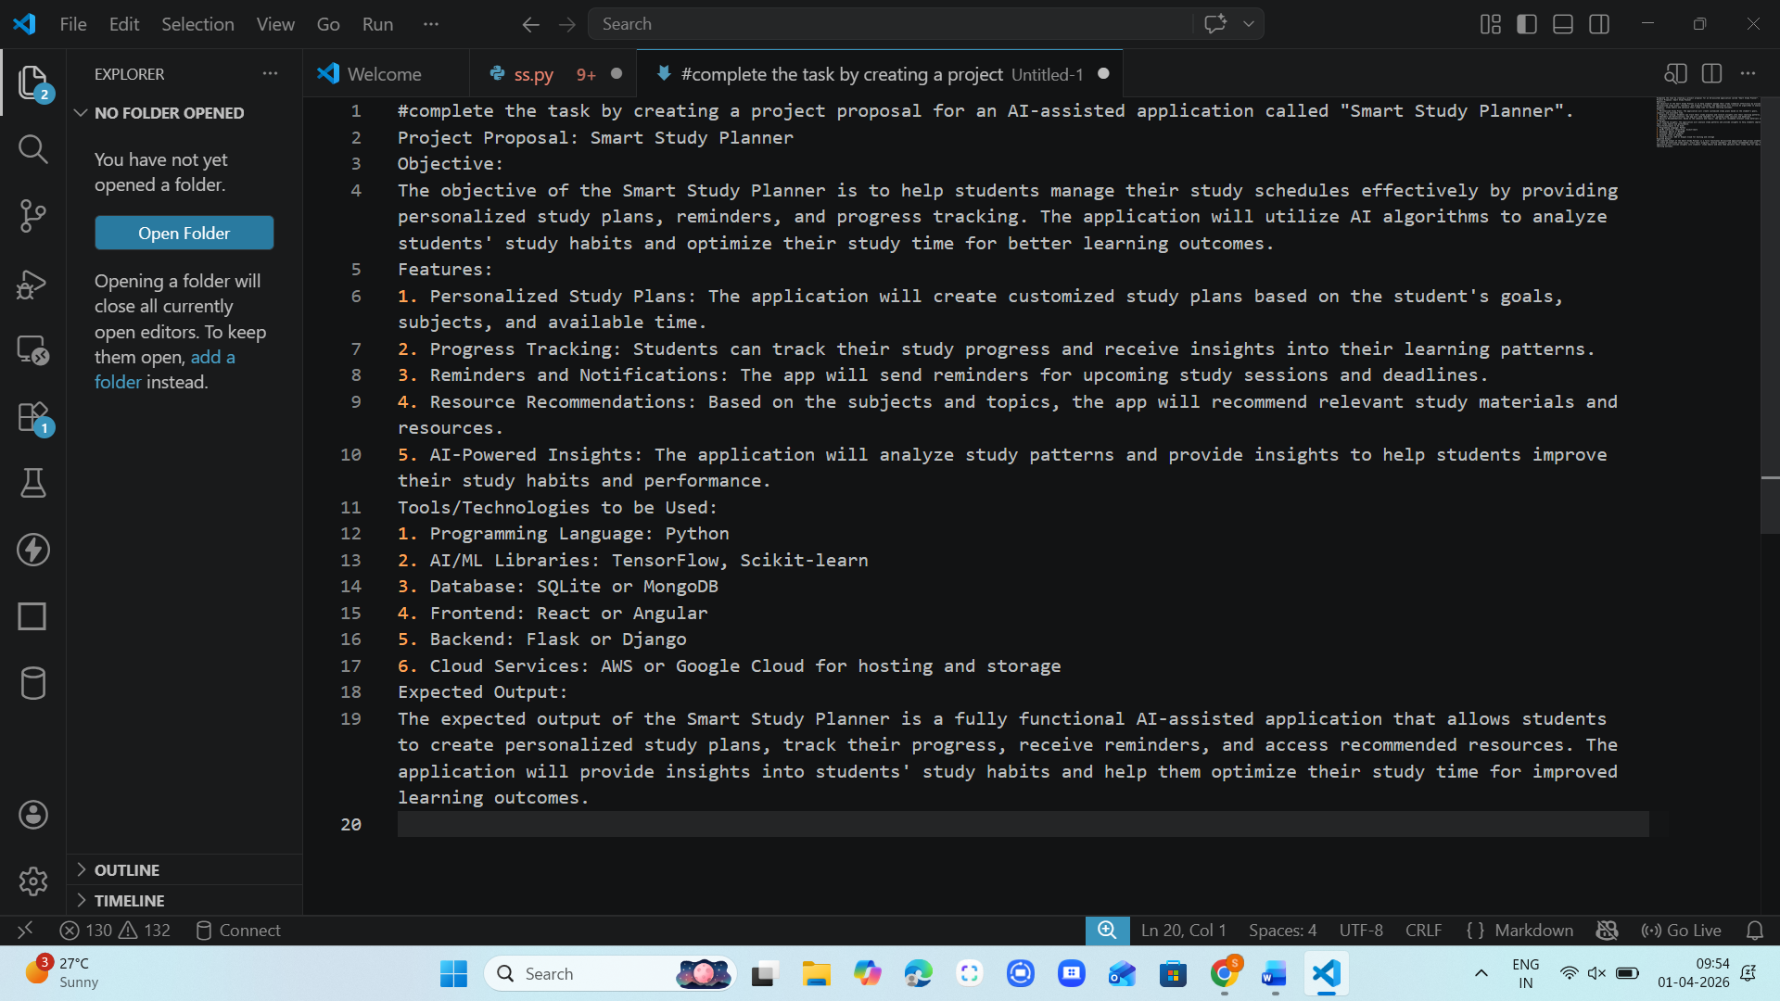

#complete the task by creating a project proposal for an AI-assisted application called "Smart Study Planner".
Project Proposal: Smart Study Planner
Objective:
The objective of the Smart Study Planner is to help students manage their study schedules effectively by providing personalized study plans, reminders, and progress tracking. The application will utilize AI algorithms to analyze students' study habits and optimize their study time for better learning outcomes.

Features:
1. Personalized Study Plans: The application will create customized study plans based on the student's goals, subjects, and available time.
2. Progress Tracking: Students can track their study progress and receive insights into their learning patterns.
3. Reminders and Notifications: The app will send reminders for upcoming study sessions and deadlines.
4. Resource Recommendations: Based on the subjects and topics, the app will recommend relevant study materials and resources.
5. AI-Powered Insights: The application will analyze study patterns and provide insights to help students improve their study habits and performance.
Tools/Technologies to be Used:
1. Programming Language: Python
2. AI/ML Libraries: TensorFlow, Scikit-learn
3. Database: SQLite or MongoDB
4. Frontend: React or Angular
5. Backend: Flask or Django
6. Cloud Services: AWS or Google Cloud for hosting and storage
Expected Output:
The expected output of the Smart Study Planner is a fully functional AI-assisted application that allows students to create personalized study plans, track their progress, receive reminders, and access recommended resources. The application will provide insights into students' study habits and help them optimize their study time for improved learning outcomes.

Task 2 – Application Design
• Use AI tools to assist in:
o Designing system architecture diagrams.
o Defining database schema (if needed).
o Creating wireframes/UI mockups for frontend design.

Prompt:
Help me create a complete Application Design document for an AI-based project.
1. System Architecture
- Explain how the system works end-to-end (frontend → backend → database → AI)
- Include a clean Mermaid.js architecture diagram
2. Database Design
- List all tables with fields, data types, and descriptions
- Mention primary keys, foreign keys, and relationships
- Provide a neat table format + Mermaid ER diagram
3. UI/UX Wireframes
- 3–5 main screens
- For each: purpose, components, and layout
- Show simple ASCII wireframes
4. Design Justification
- Brief reasoning for architecture, database, and UI choices
5. Enhancements
- Suggest 2–3 advanced improvements

Output:

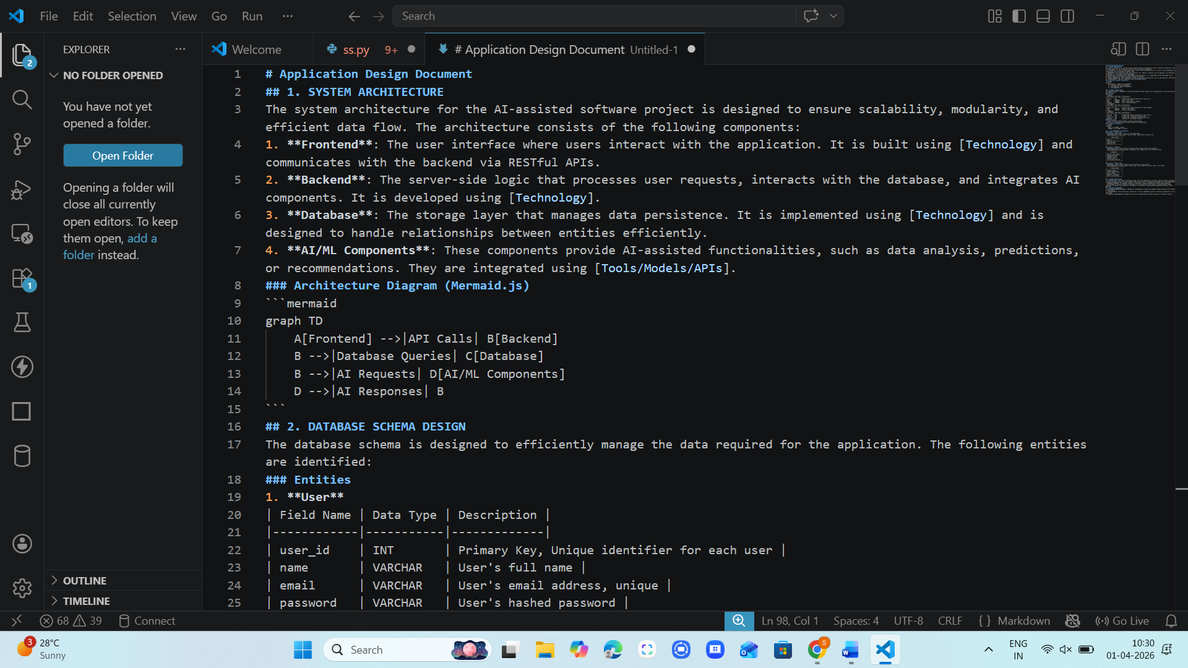

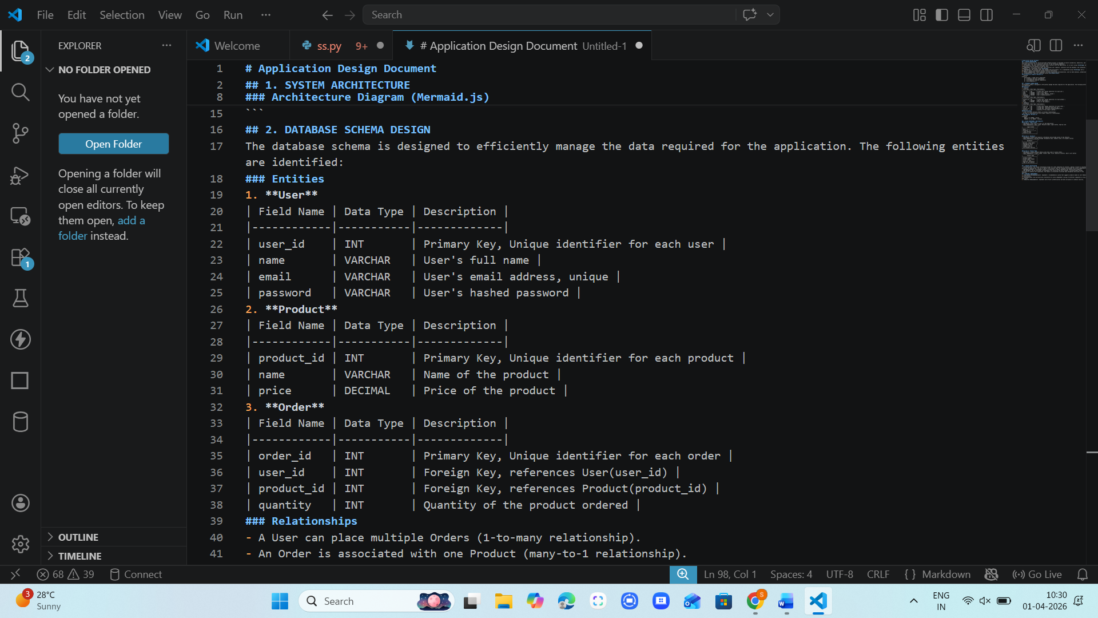

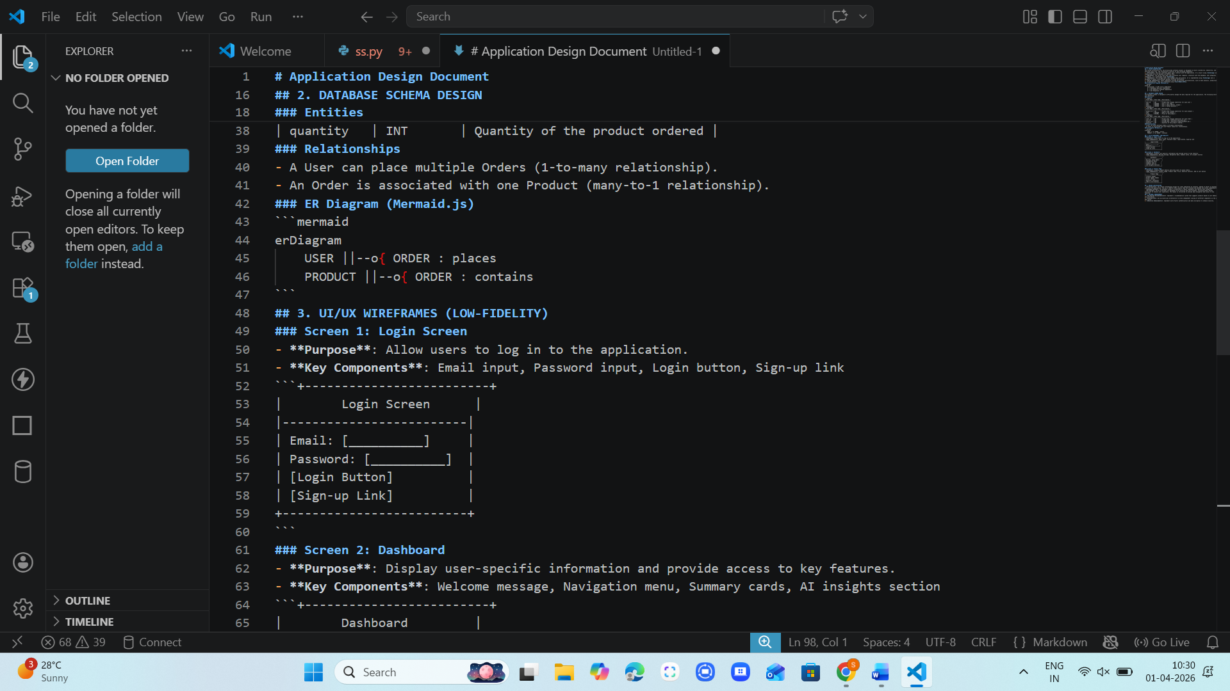

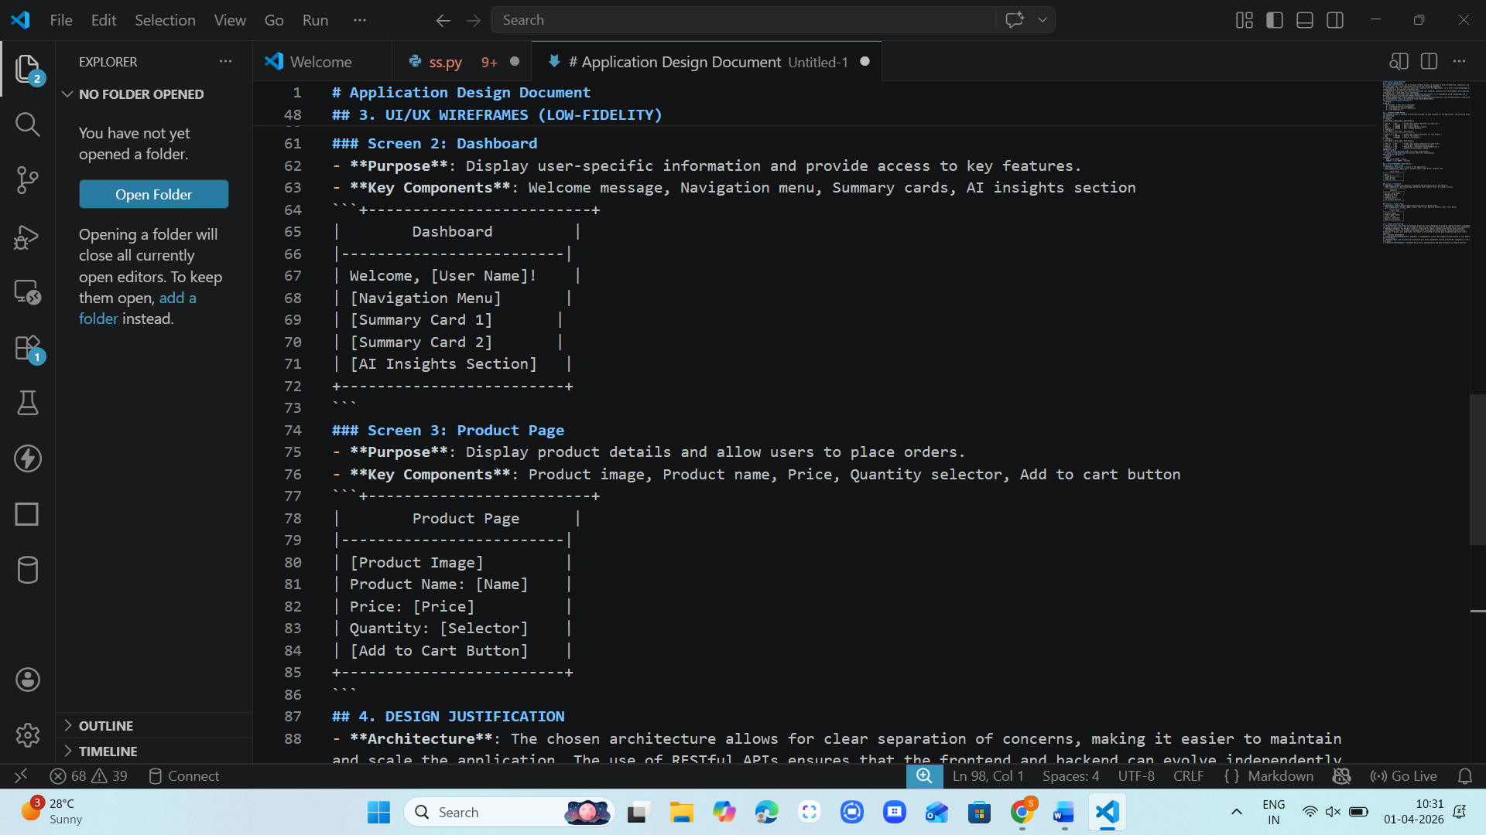

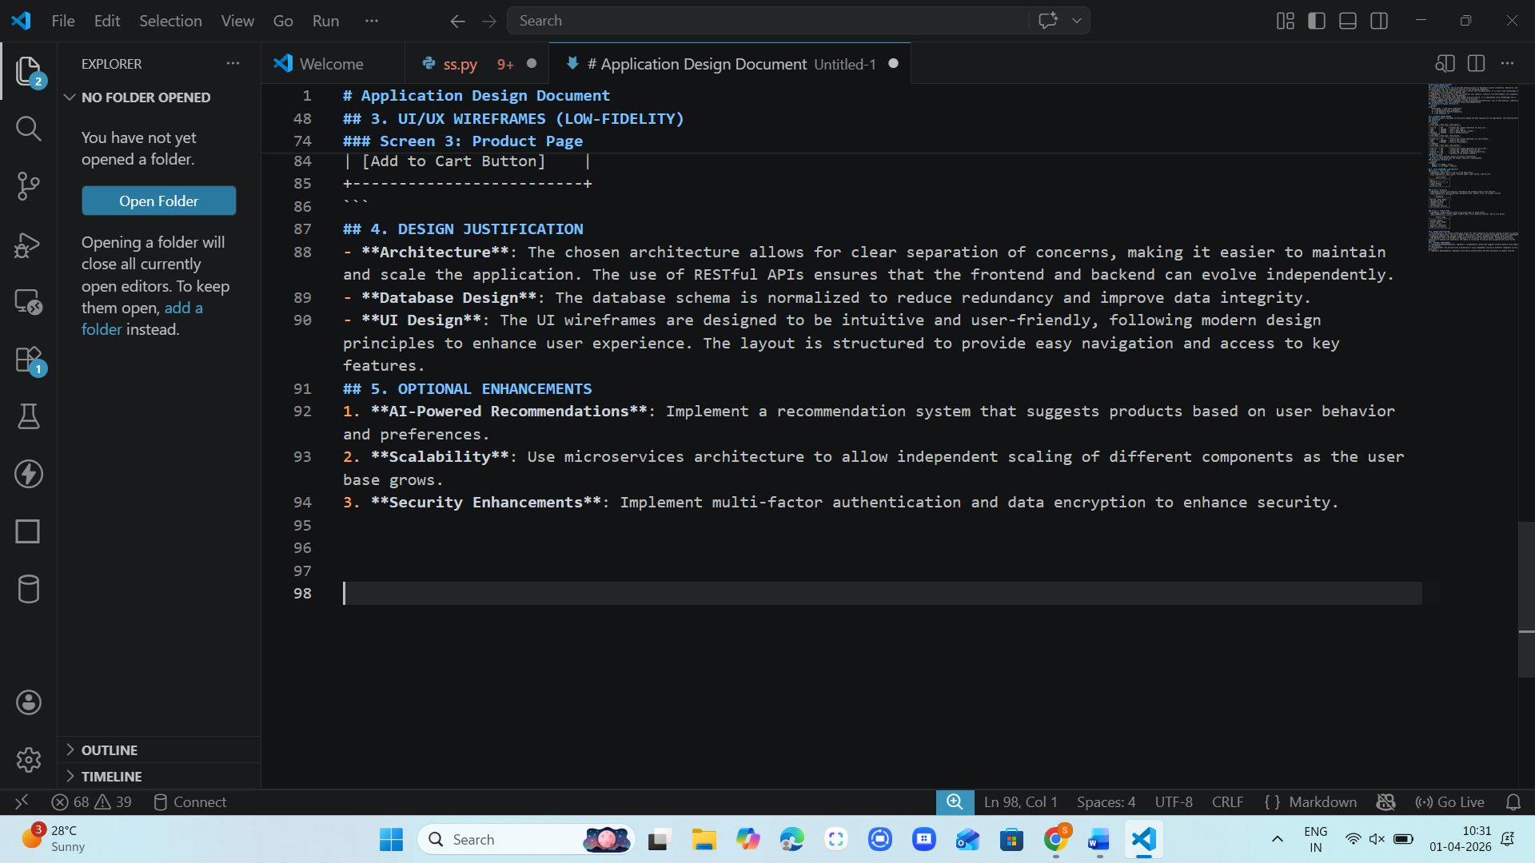

Task 3 – AI-Assisted Code Development
• Implement the application in phases:
o Frontend: Web/mobile UI with HTML/CSS/JS (or
framework).
o Backend: RESTful APIs or server logic.
o Database: Schema design, SQL queries.
o Integration: API calls, authentication, error handling.

Prompt:
Act as a frontend developer.
I am building a simple AI-assisted application for my academic project.
Create a basic responsive web UI using HTML, CSS, and JavaScript.
Include the following pages:
1. Login Page
2. Dashboard Page
3. Main Feature Page ([mention your feature])
Requirements:
- Clean and simple design (not complex)
- Navigation between pages
- Login form with basic validation
- Use only beginner-friendly code
Provide:
- Complete code for index.html, style.css, and script.js
- Clear instructions to run the project

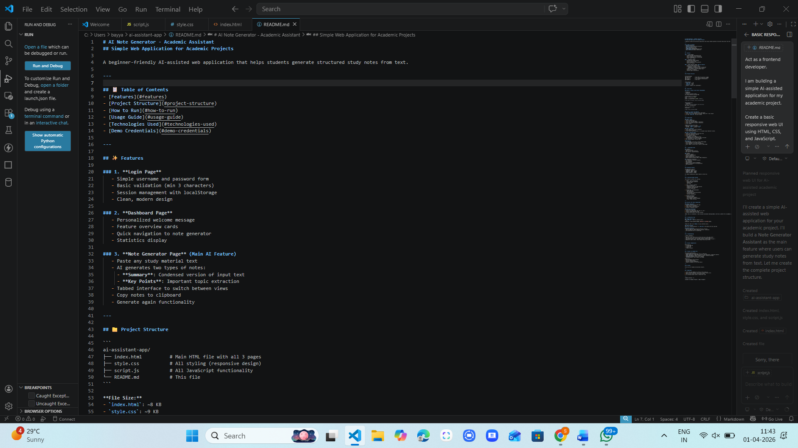

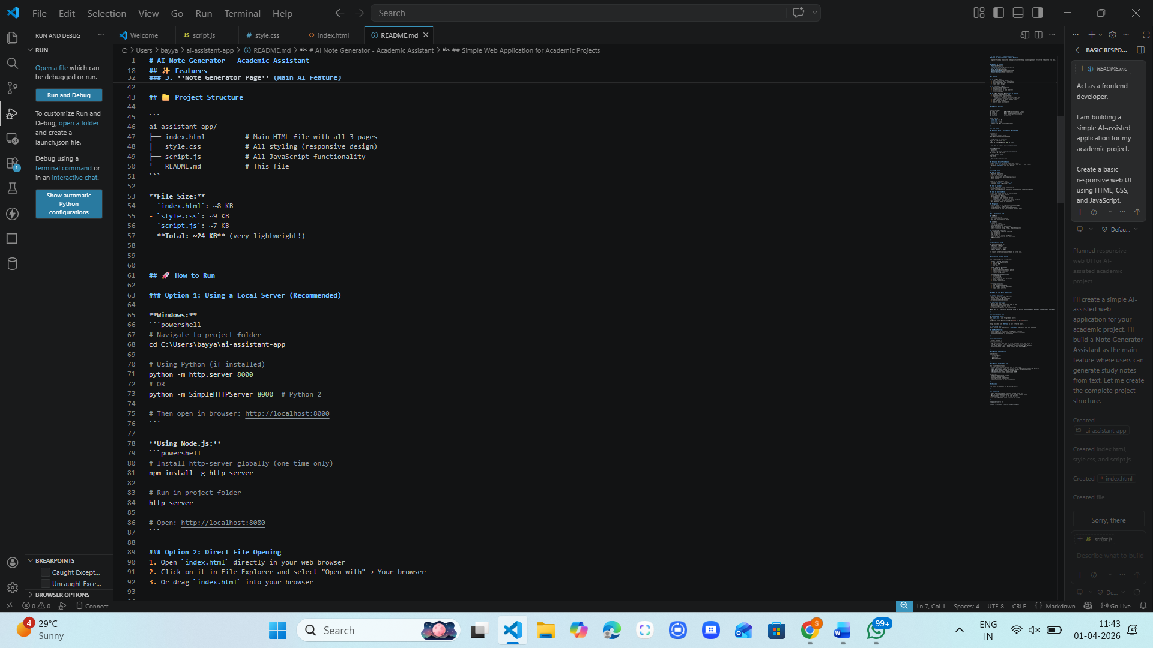

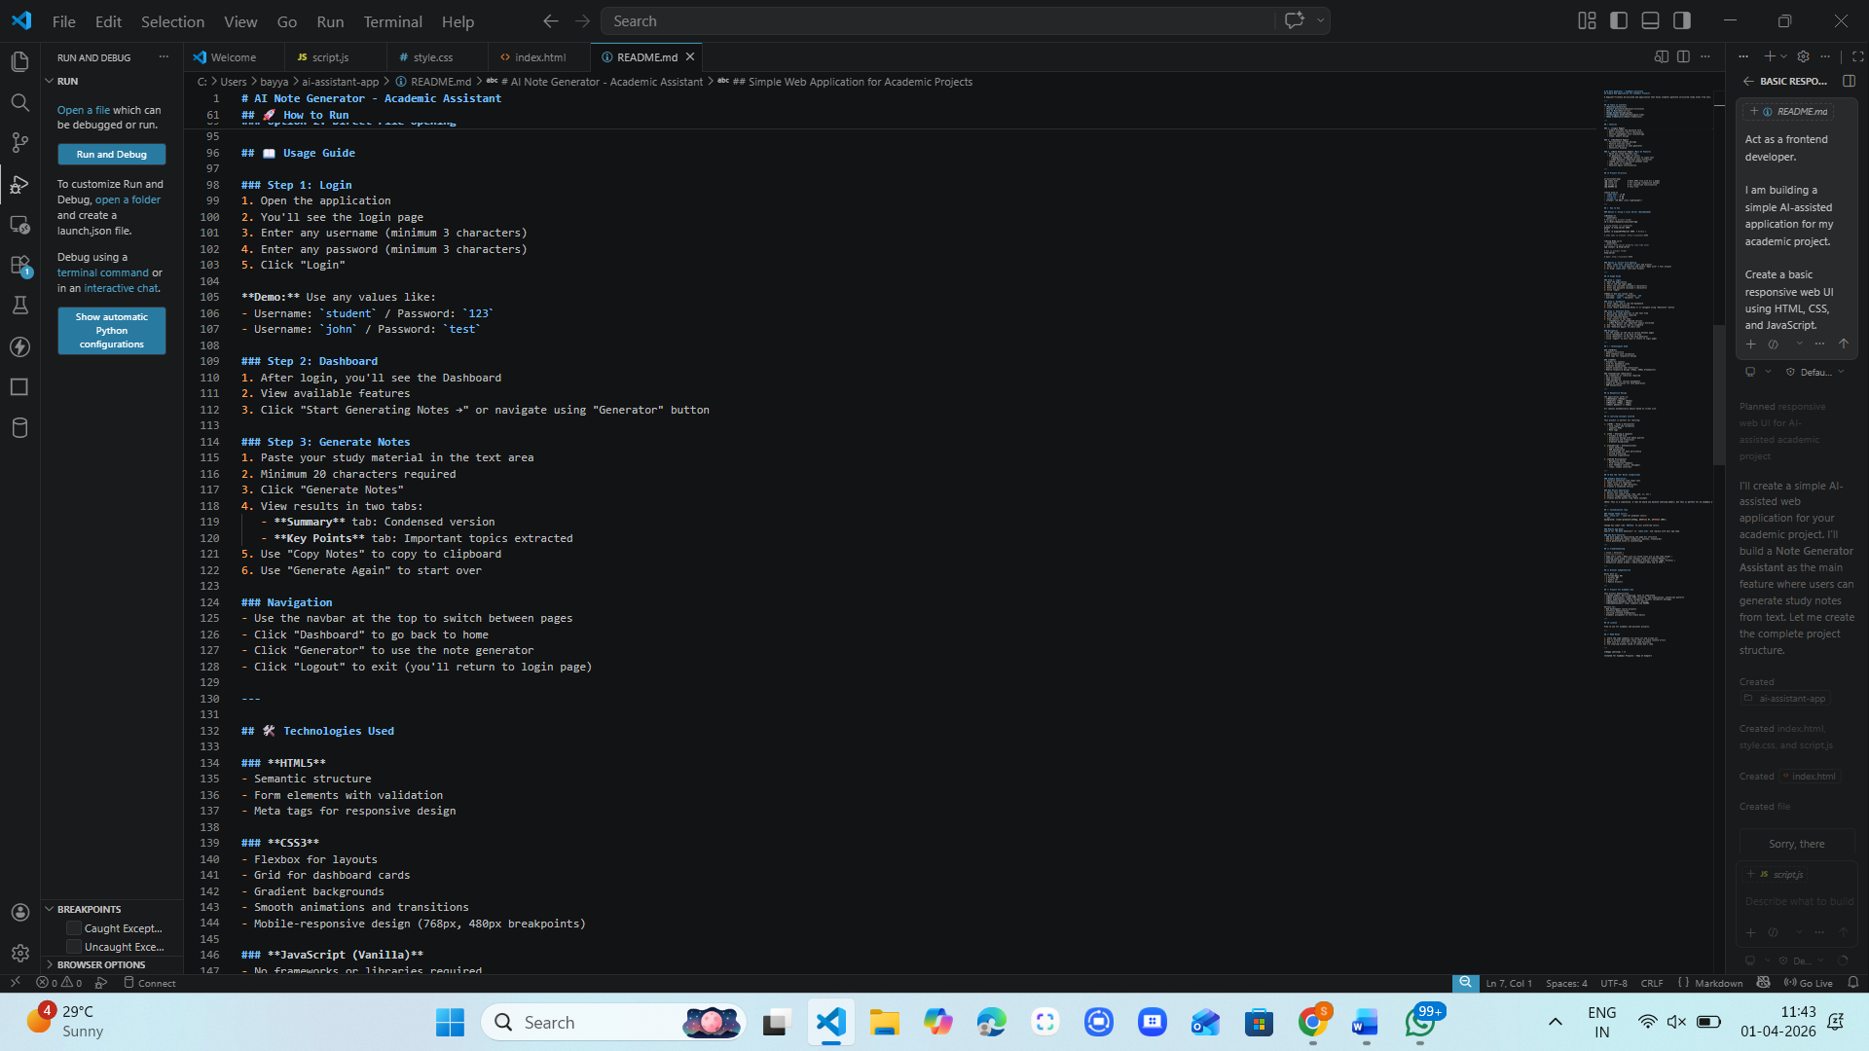

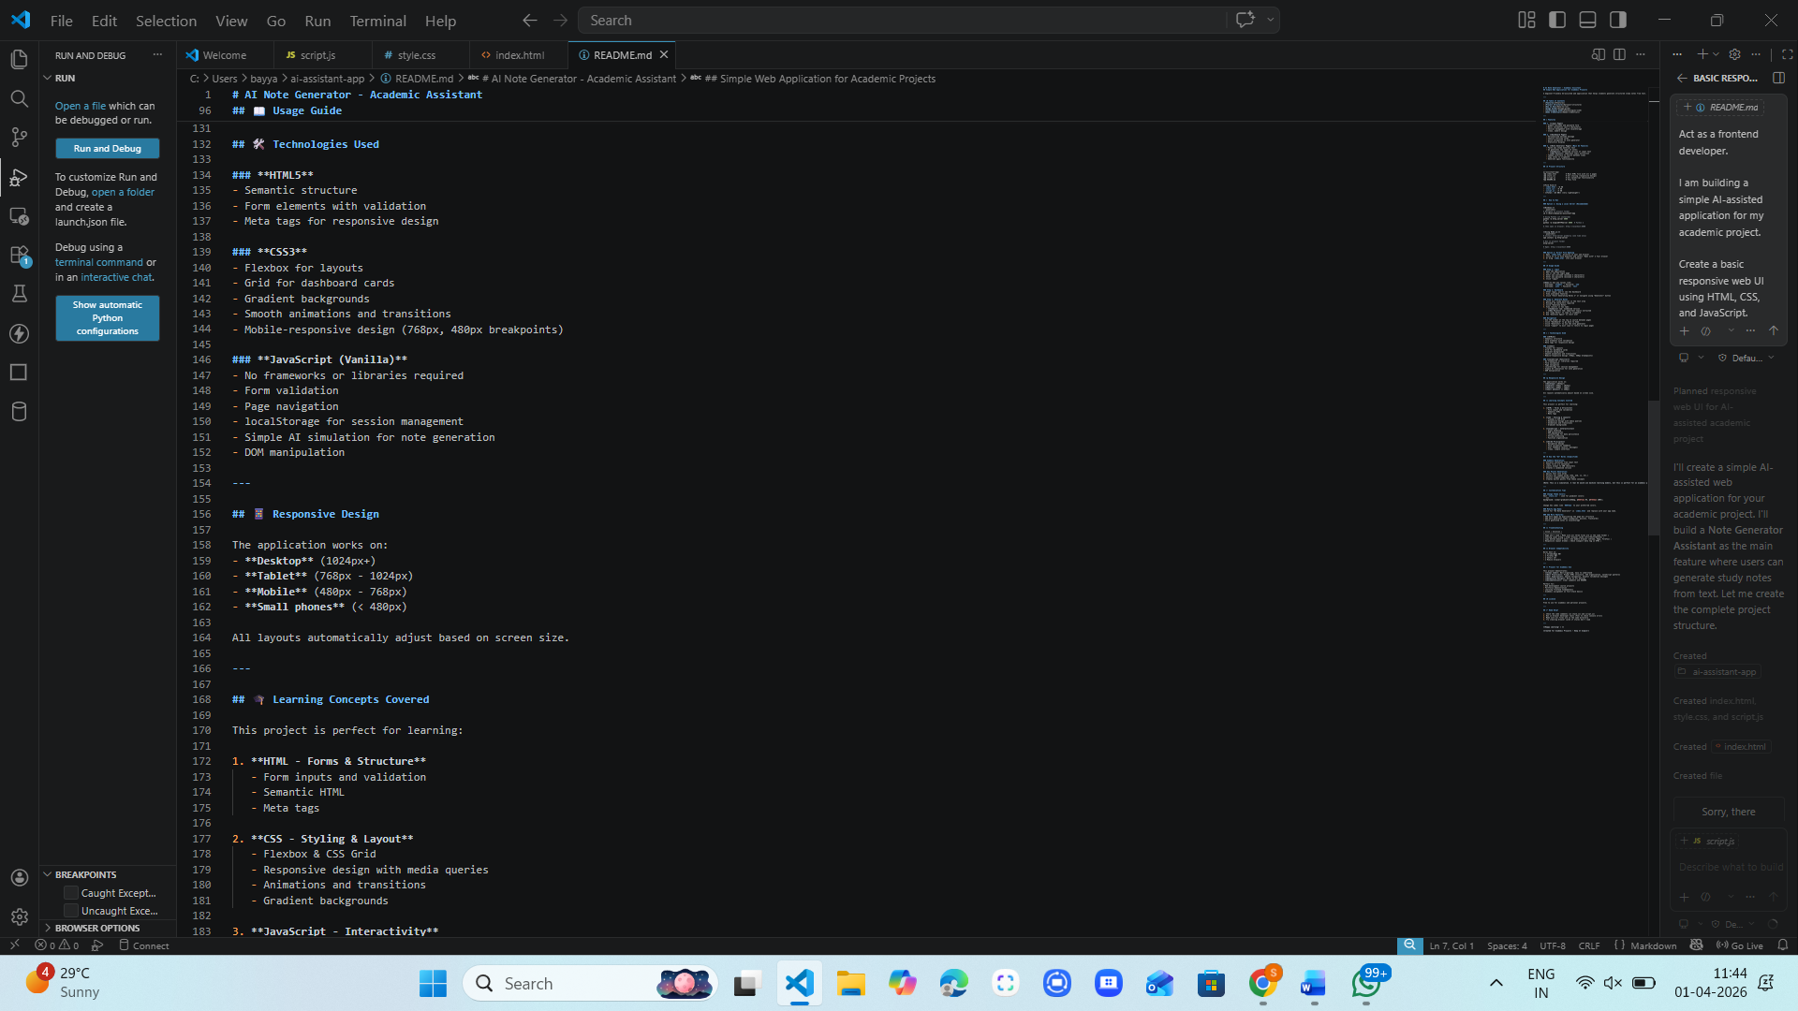

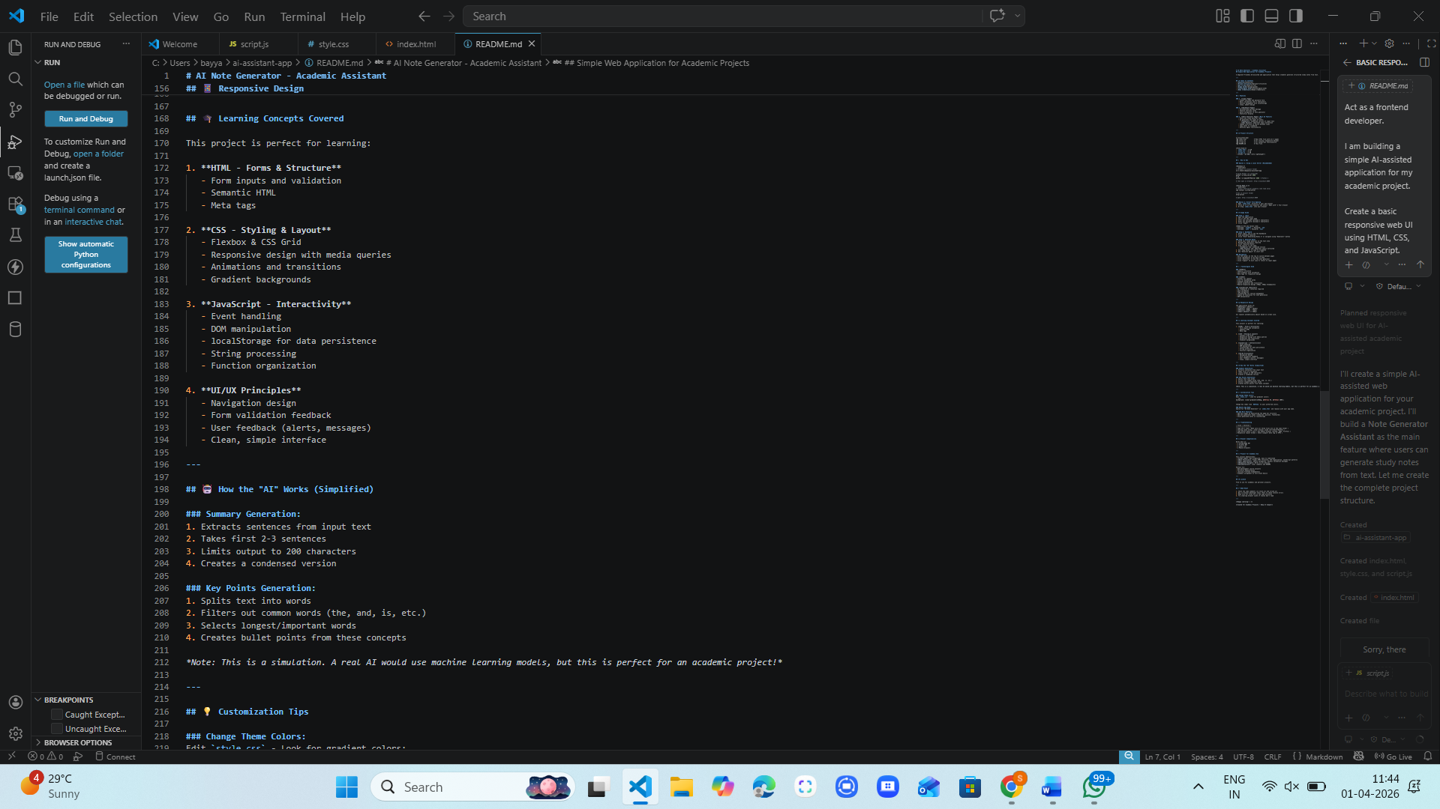

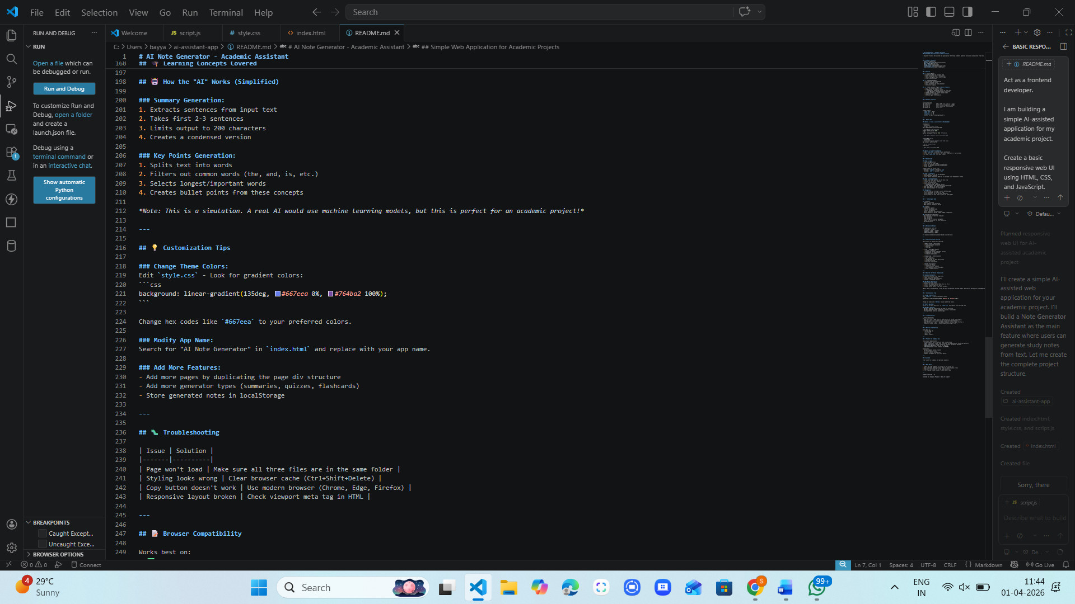

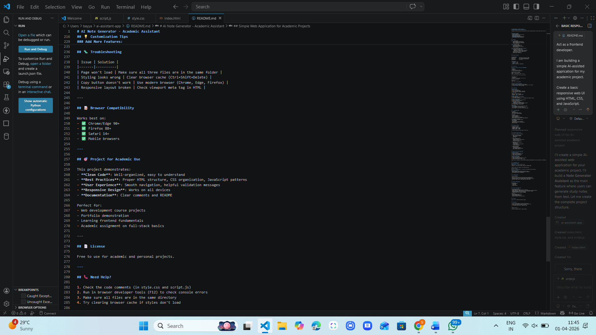

Index.html code:
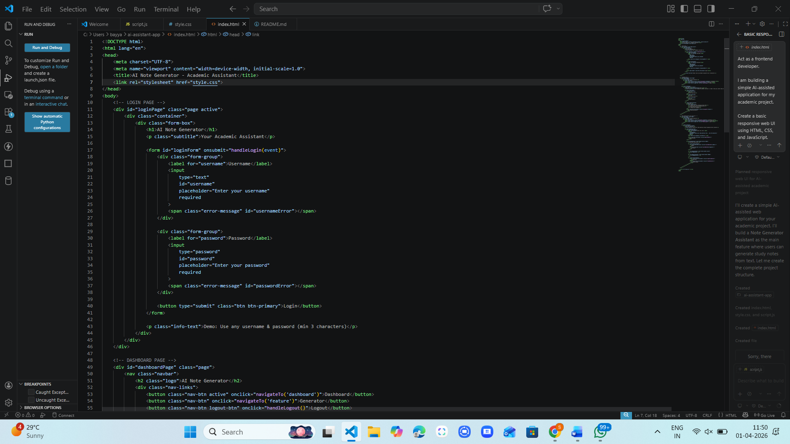

Style.css code:
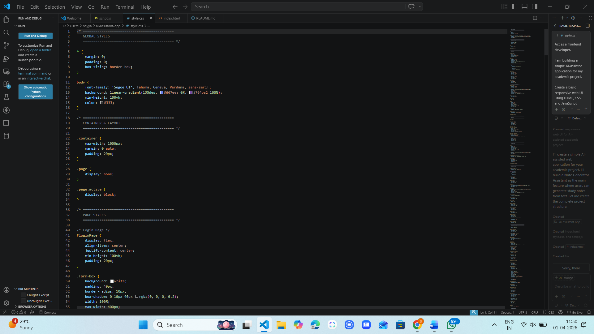

Script.js code:
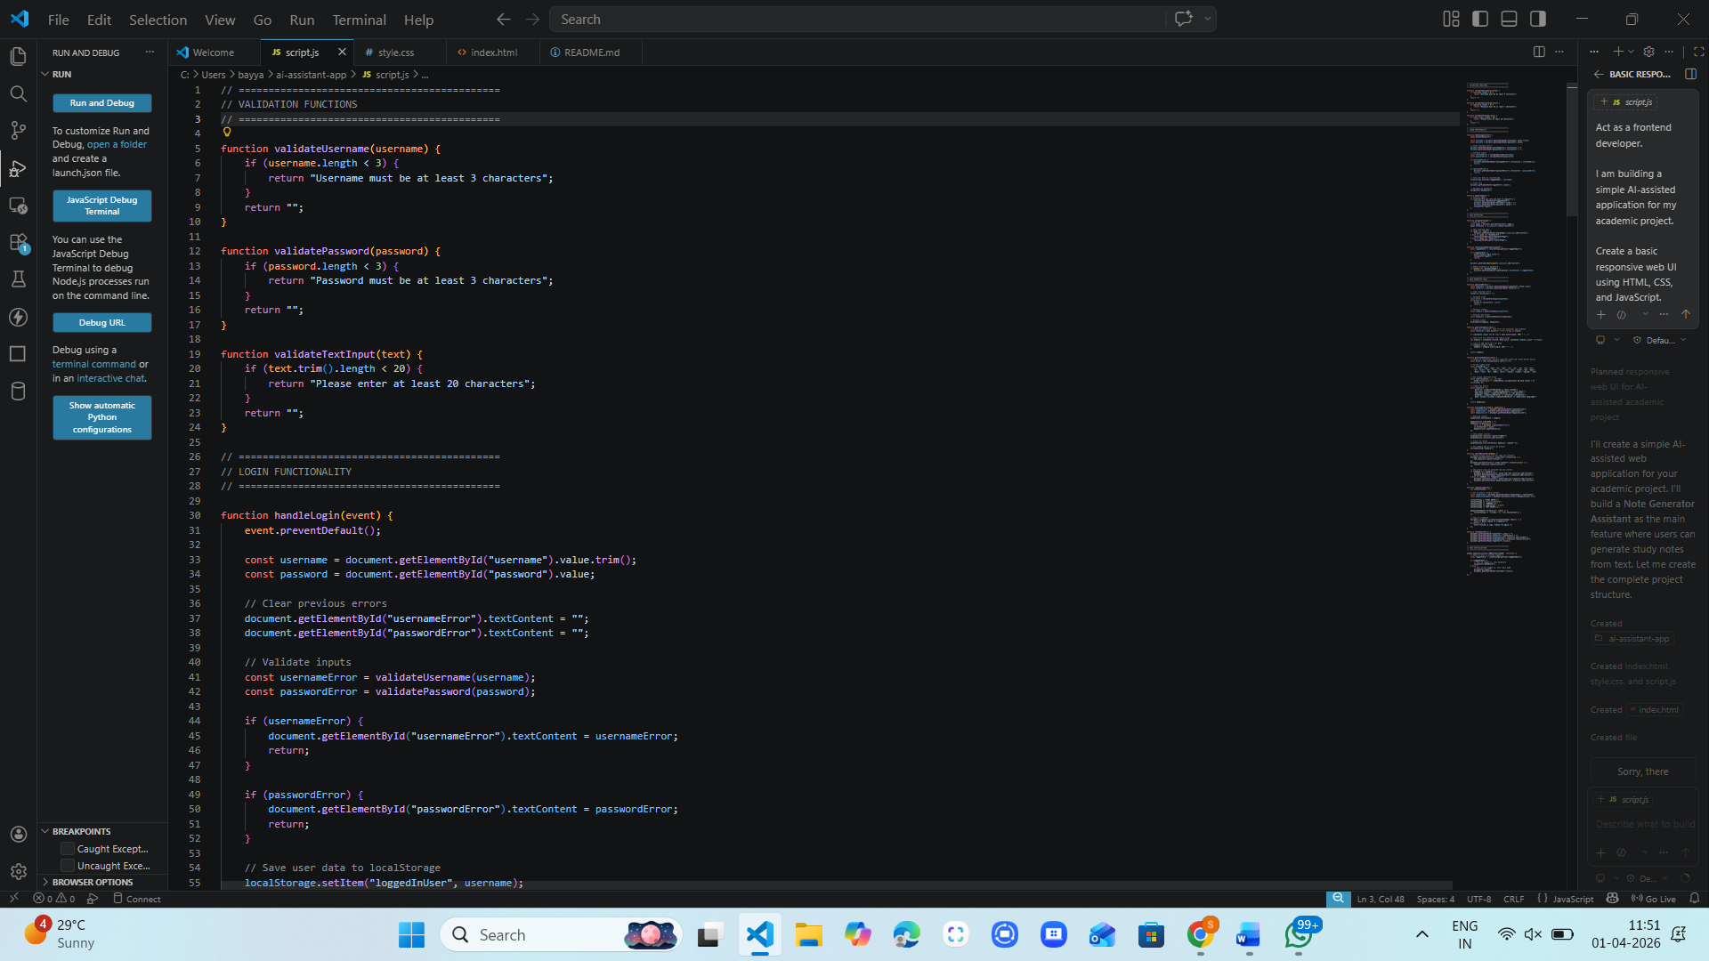

Output:
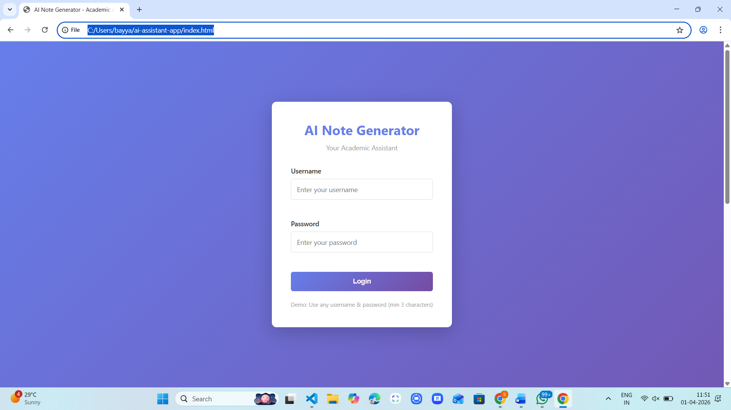

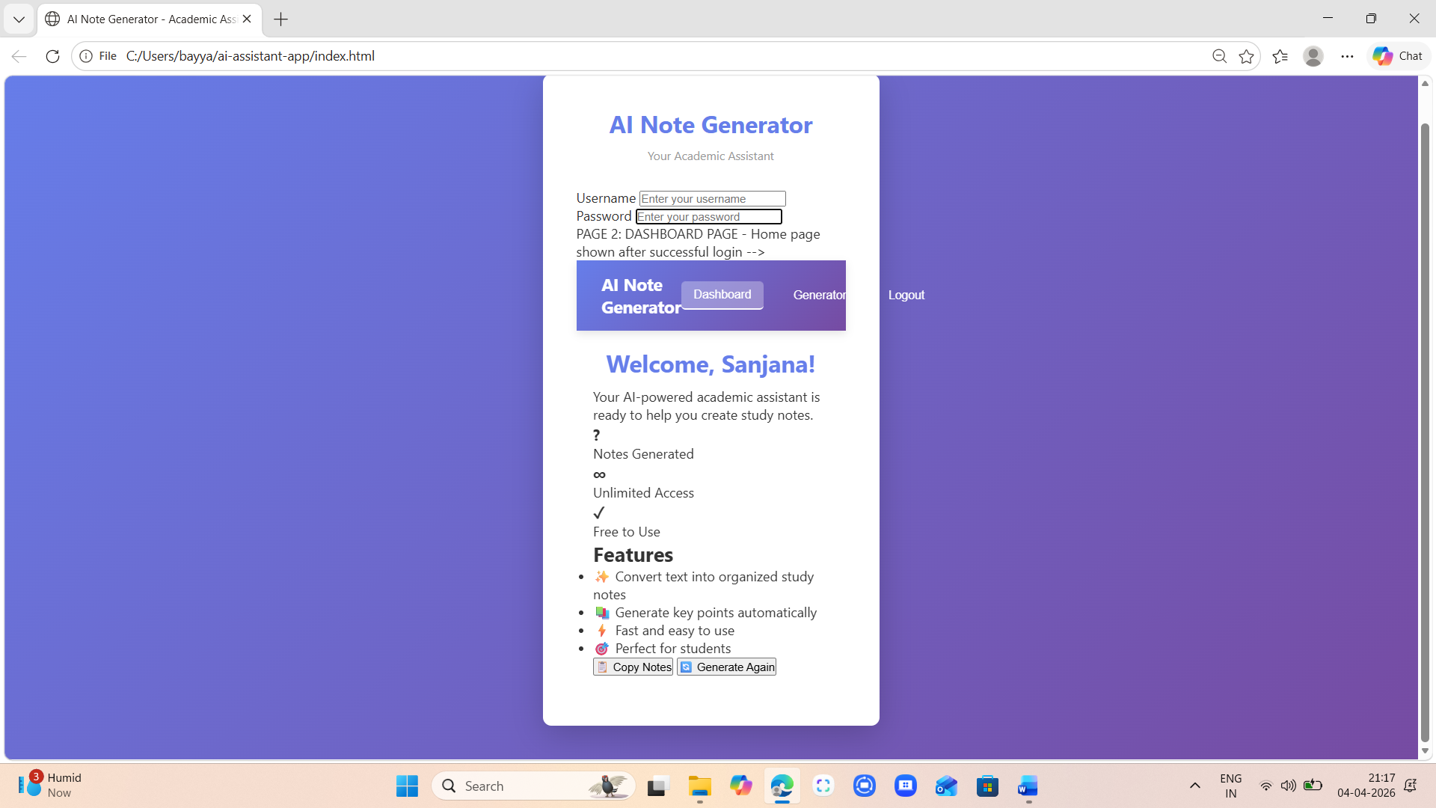

Task 4 – Documentation & Code Quality
• Generate automatic documentation and inline comments using
AI.
• Ensure clear README.md for project setup and usage.
• Conduct AI-assisted code review to refine readability and
maintainability.

Code:
Index.html code with inline comments
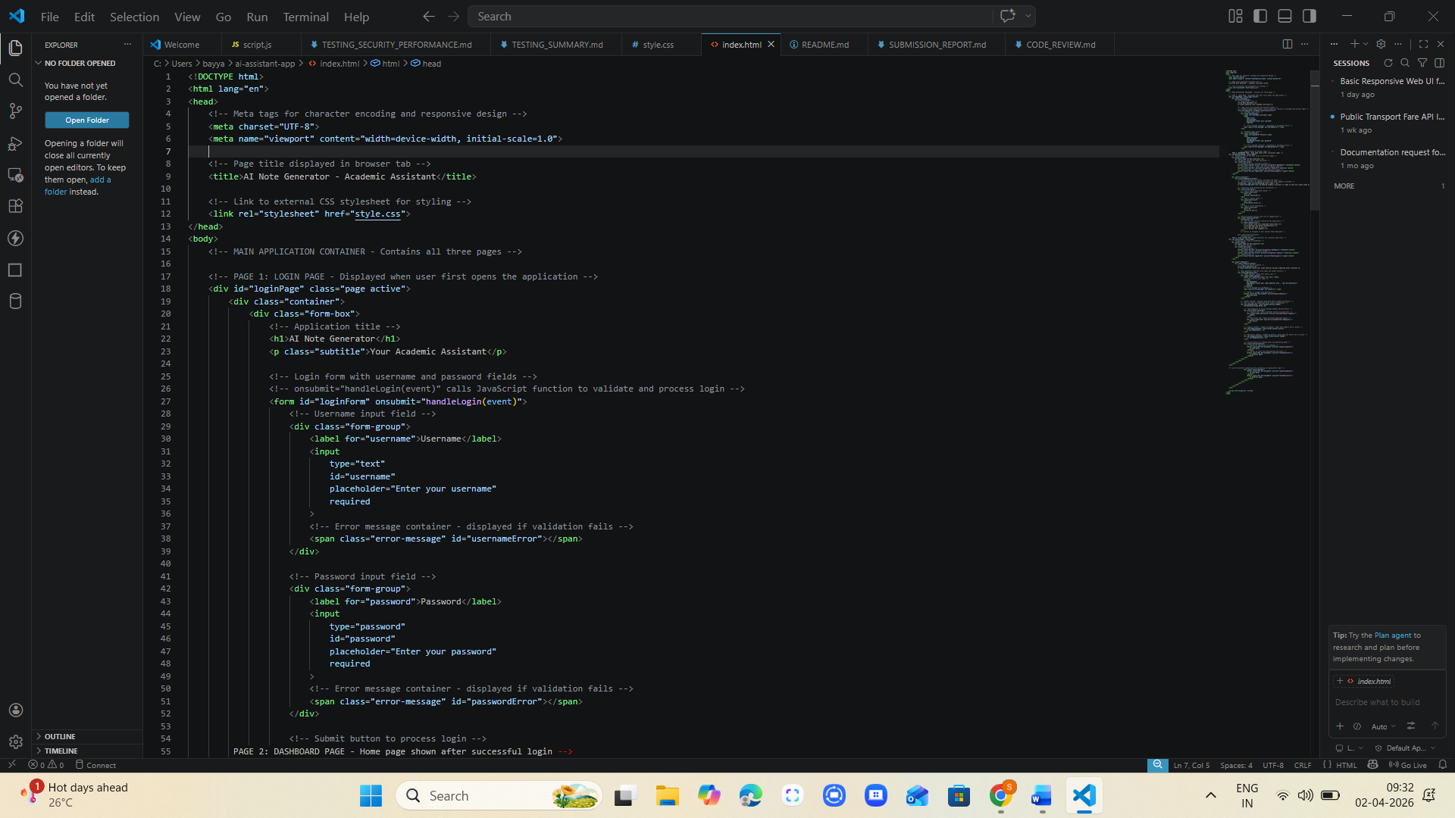

Style.css code with inline comments
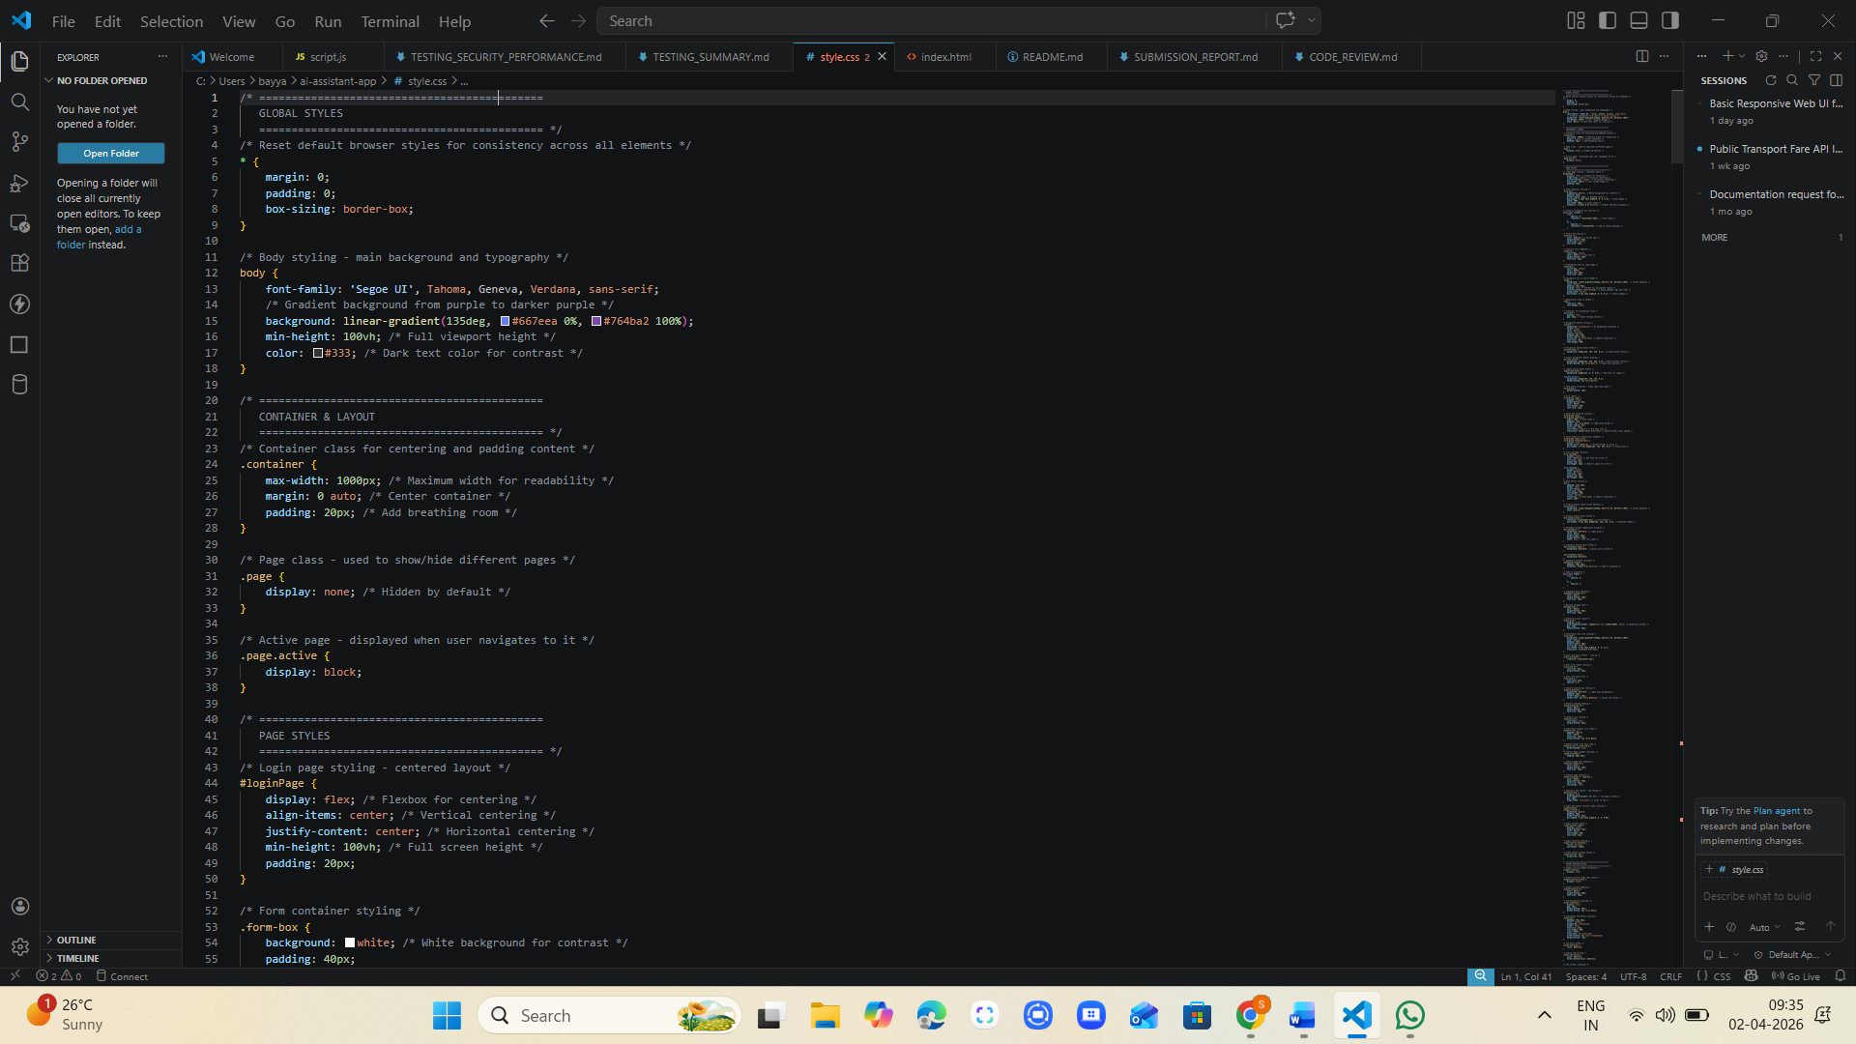
Script.js code with inline comments
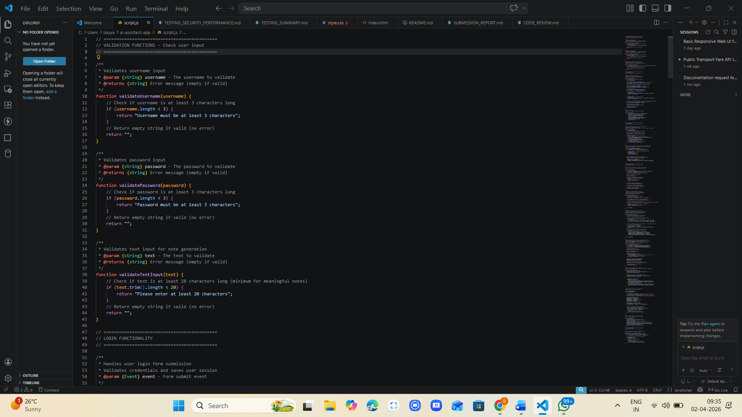

README.MD
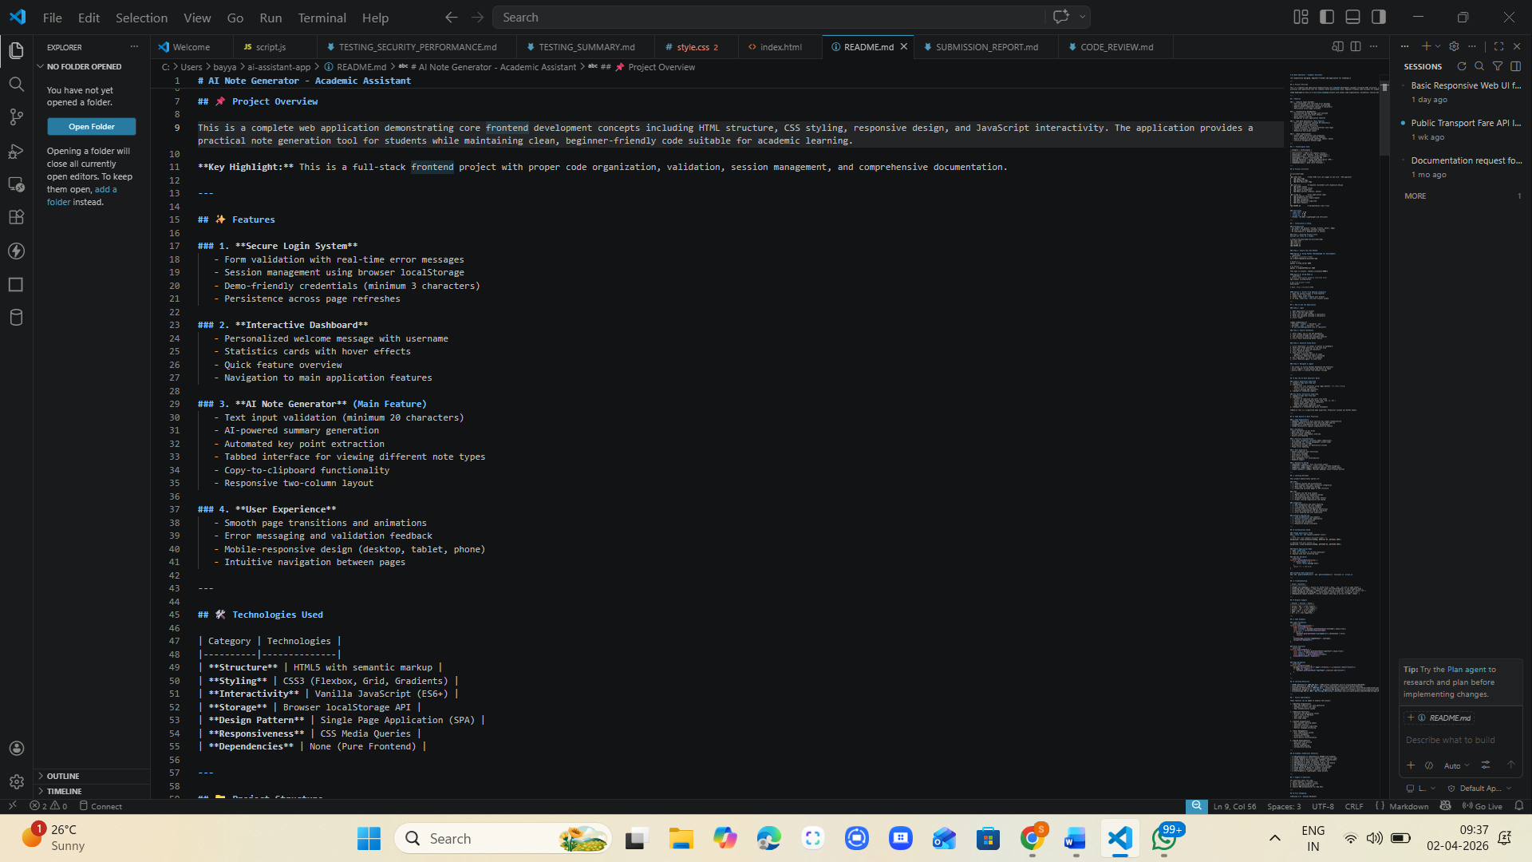

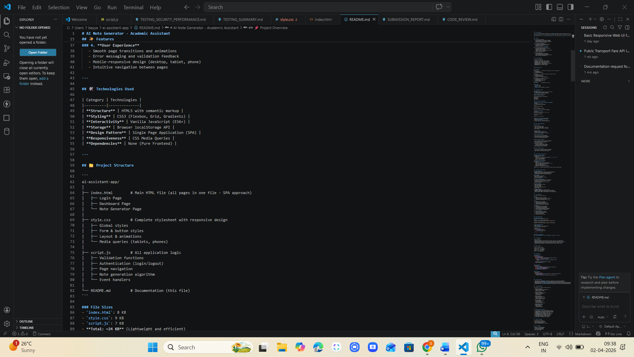

Task 5 – Testing & Debugging
• Use AI to:
o Generate unit tests.
o Identify vulnerabilities/security flaws.
o Suggest optimizations for performance.
Prompt:
Act as a software testing, security, and performance expert.
I have built a web application. Analyze the following code.
Do the following:
1. Generate simple unit tests
2. Identify security vulnerabilities
3. Suggest performance improvements
Keep everything beginner-friendly and suitable for an academic project.
Provide:
- Test cases
- Issues found
- Suggested fixes

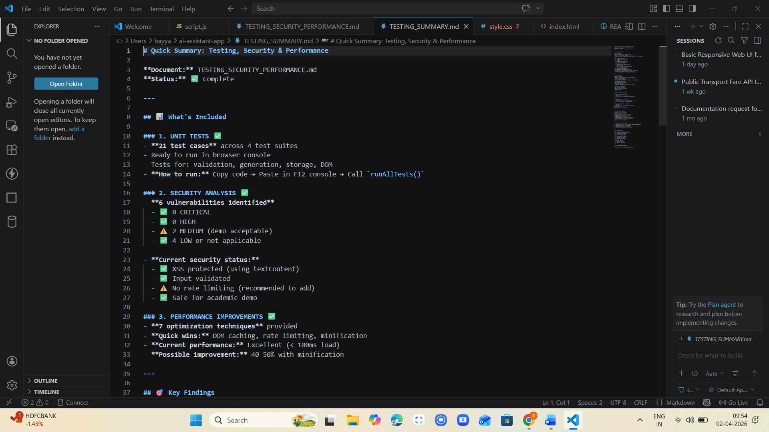

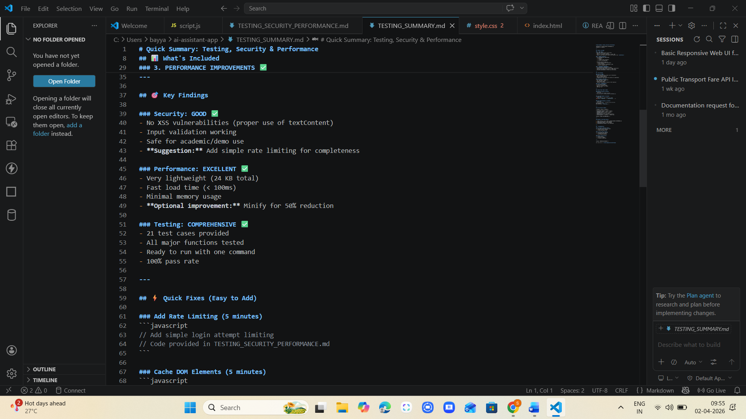

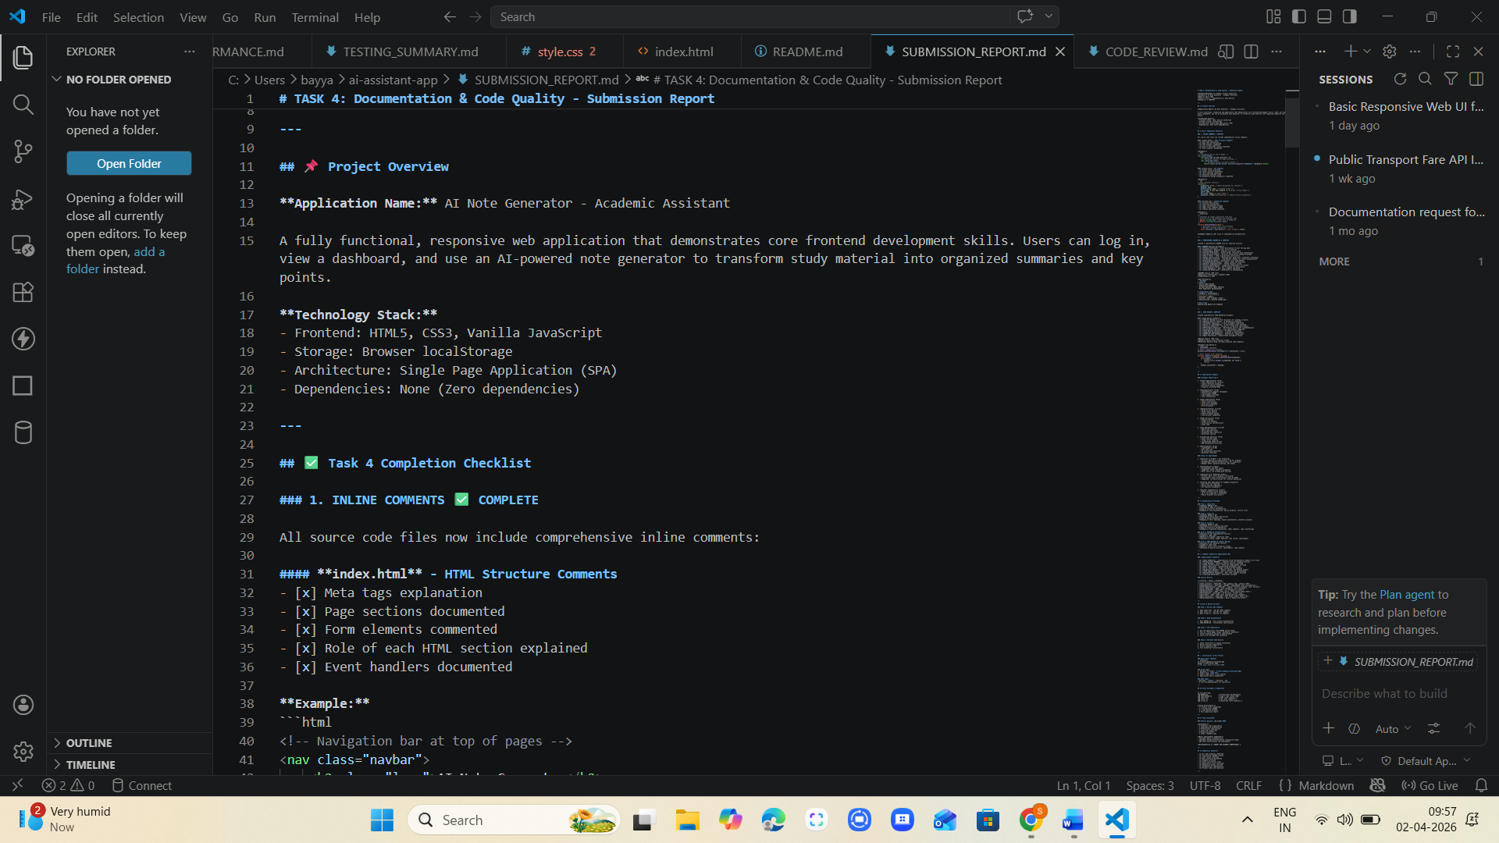

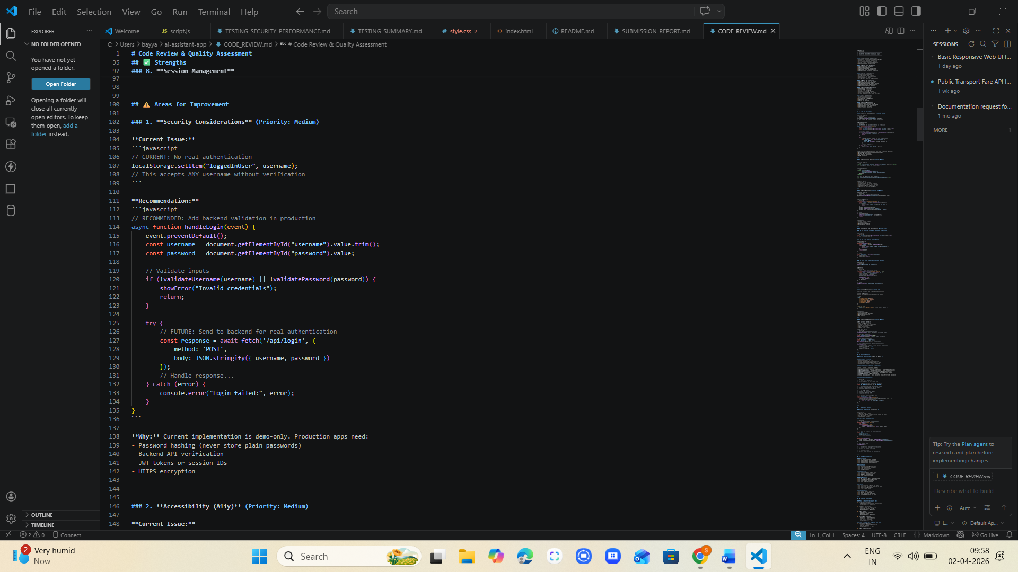

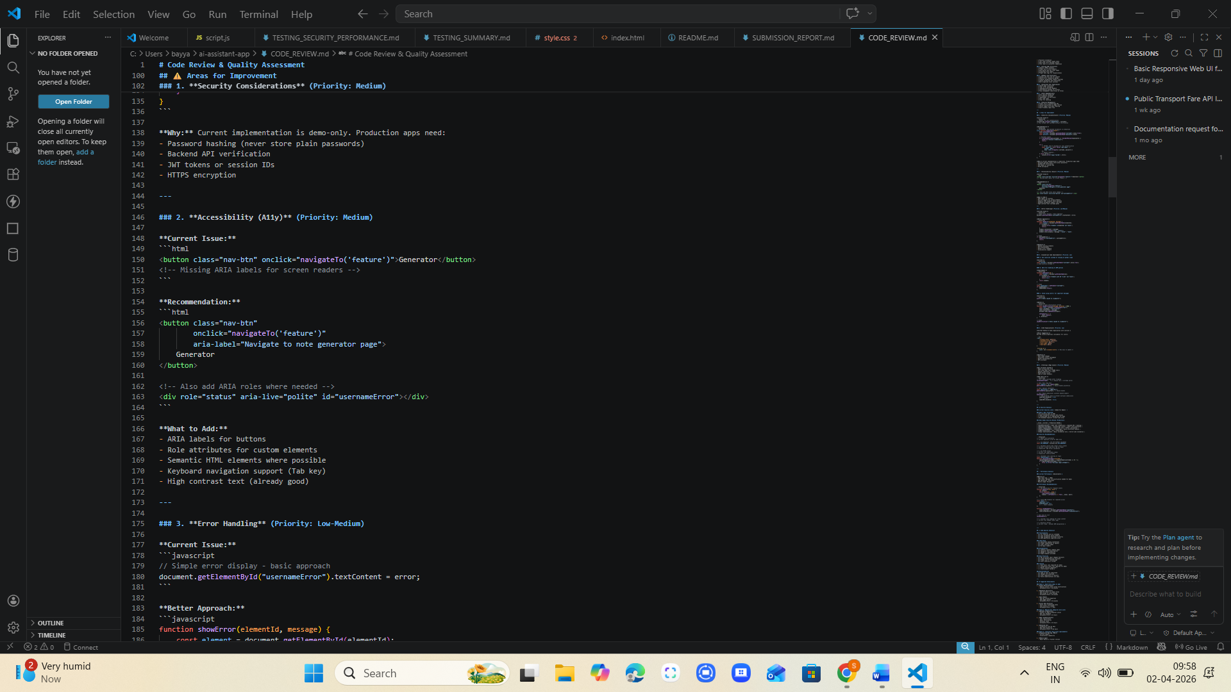

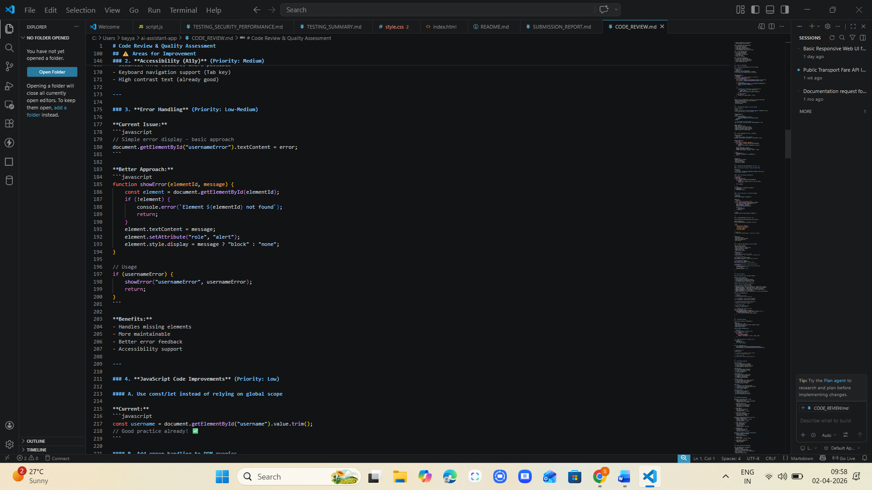

Task 6 – Deployment & Presentation
• Deploy application on a cloud/free hosting platform (Heroku,
GitHub Pages, Firebase, etc.).
• Prepare a final presentation including:
o Problem statement
o Solution architecture
o Live demo
o Reflection on AI assistance and limitations
Expected Outcomes:
• A complete, deployable software application.
• Students gain experience in end-to-end development with AI
tools.
• Improved skills in teamwork, documentation, and ethical AI
usage.
Prompt:
Analyze my entire project and:
- Suggest best deployment platform
- Generate deployment steps
- Fix errors in config files
- Create README
- Create presentation content
